**IT Project Management (IT3040)**

**Assessment on Tools**

|  |  |  |
| --- | --- | --- |
| **Group Number** | **REG WE 69** | |
| **Name** | | **Registration No** |
| Pathirana M.P.C.D | | IT19092898 |
| Bandara M.A.Y.P.W | | IT20162382 |
| Silva K.V | | IT20126292 |
| Jayawardana J.K.M.D.T | | IT20129576 |

**Table of Contents**

Azure Boards 1

SonarQube 2

GitHub 3

Selenium 4

# Azure Boards

1. **Project Overview**

1. **Graphical user interface, text, application, email

   Description automatically generatedBacklog**
2. **Graphical user interface, text, application

   Description automatically generatedSprints**
3. **Graphical user interface, application

   Description automatically generatedTaskboard**
4. **Chart

   Description automatically generatedSprint burndown chart**
5. **Chart

   Description automatically generatedCumulative Flow diagram**

# SonarQube

1. **Overview status of analyzed projects**

1. **Project overview**

1. **Project Issues**

# GitHub

1. **Repository view**

1. **File Setup**

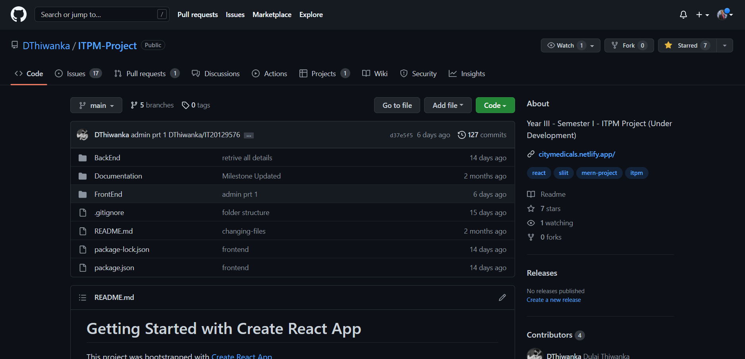

1. **Branches**

1. **Graphical user interface

   Description automatically generatedContributors**
2. **Commit Activity**

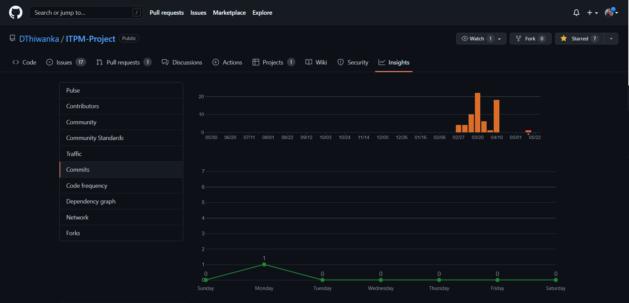

1. **Code Frequency**

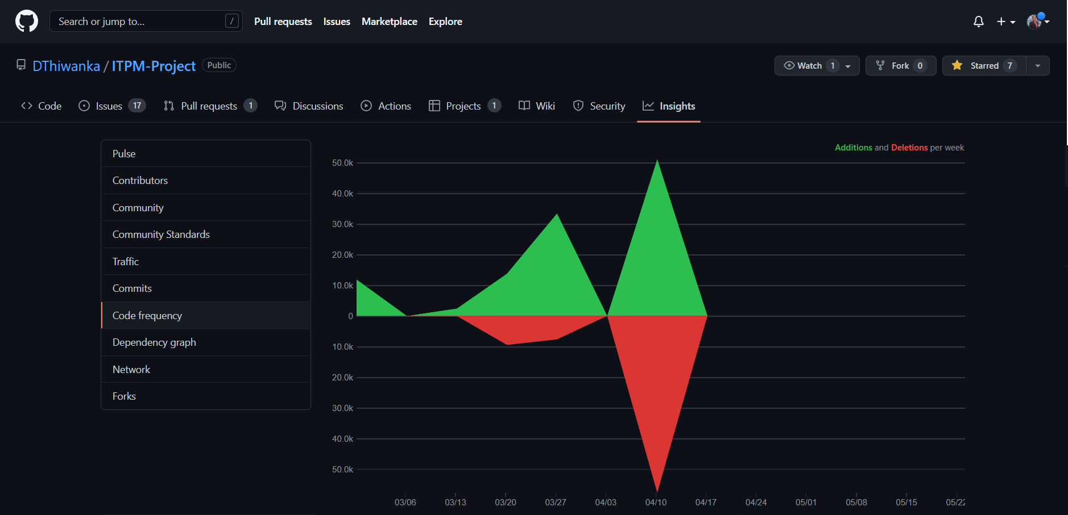

1. **Pulse**

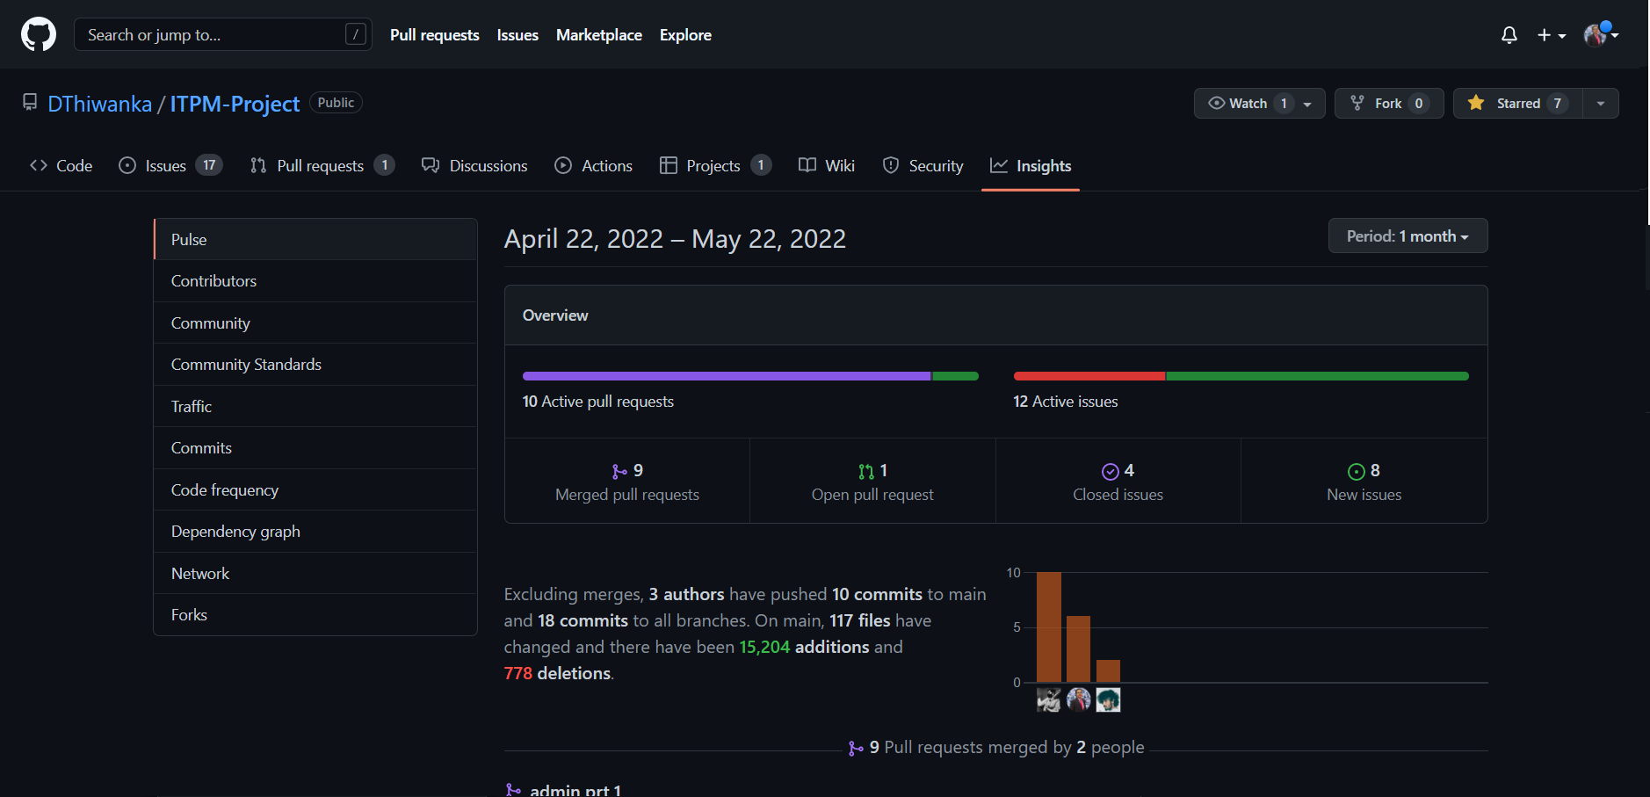

1. **Commit History**

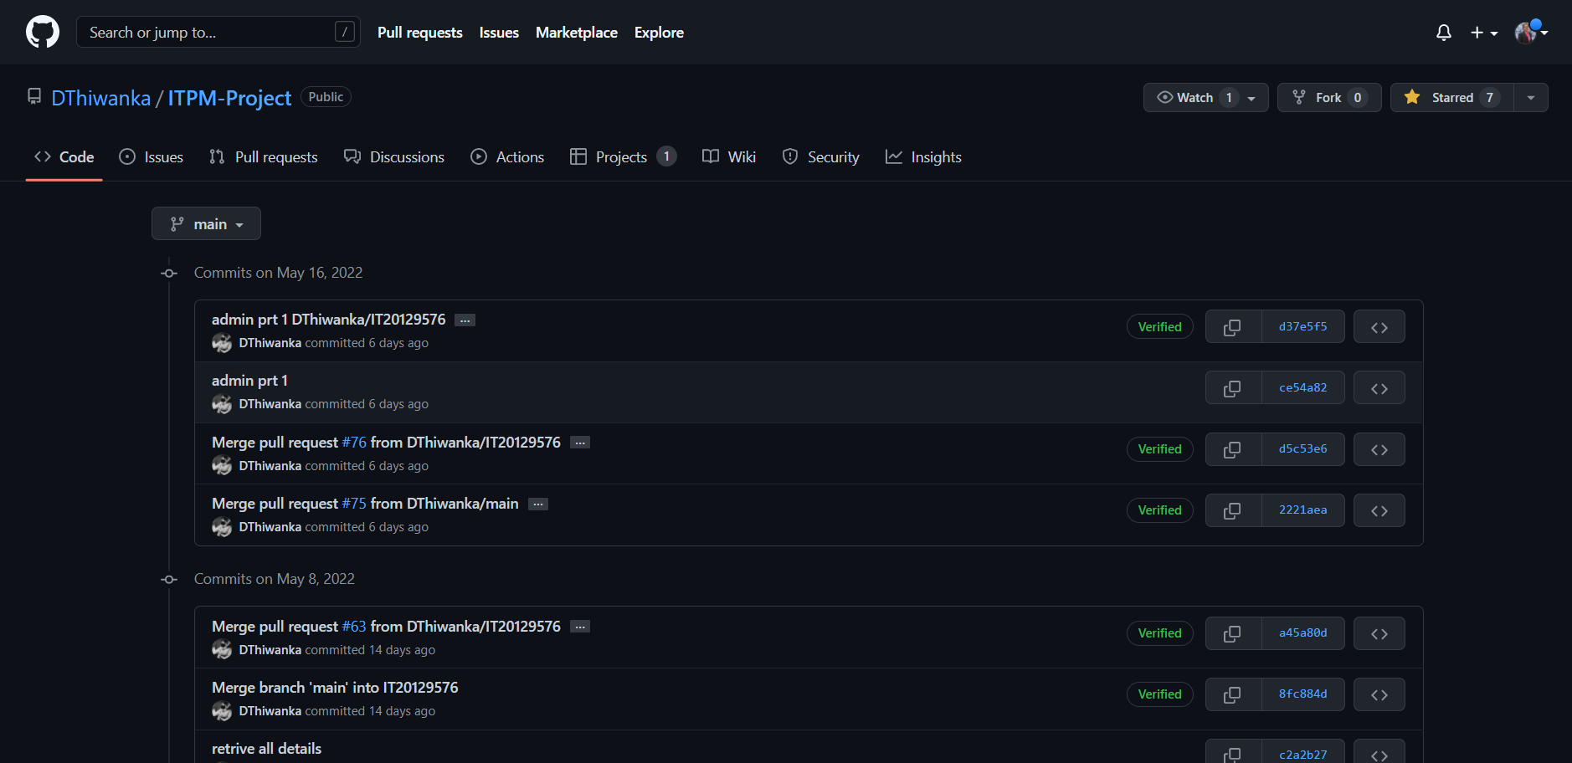

1. **ReadMe**

# Selenium

1. **Selenium IDE with the base URL**

1. **Automation Test Script**

1. **Selenium IDE after running the test case**

1. **Verify items on the page**

